# How to install Lubuntu virtual machine using VirtualBox

# Bill Erhard

# Renton Technical College

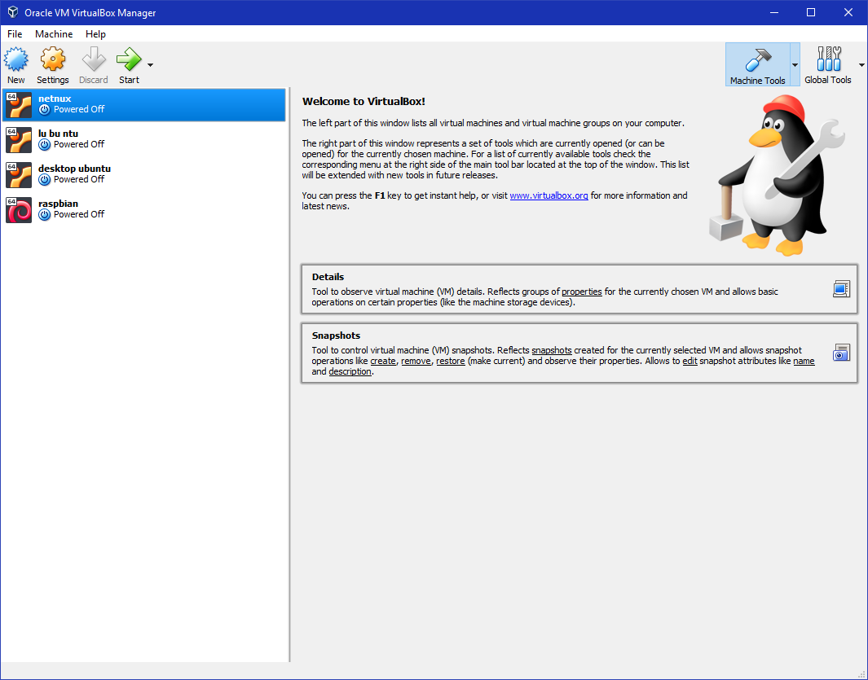

1. To begin, click the New button in the upper left corner. 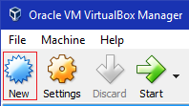
2. 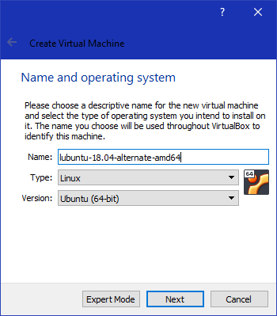A new window will pop up guiding you through setup. Start by giving your virtual machine an appropriate name, type, and version. For lubuntu-18.04-alternate-amd64, use Type = Linux, Version = Ubuntu (64-bit). Then, click “Next”.
3. 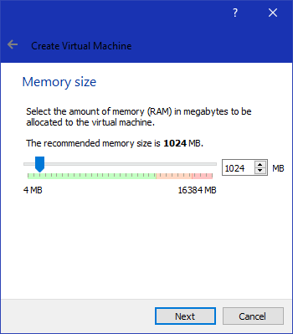Allocate memory for the virtual machine. The default amount of memory is 1024 MB, which should be enough for lubuntu. Click “Next”.
4. 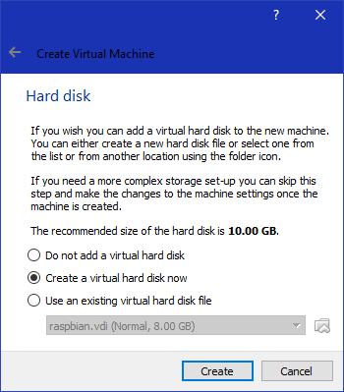Next, VirtualBox prompts the user for a hard disk. To create a new hard disk, select “Create a virtual hard disk now” and click “Create”.
5. 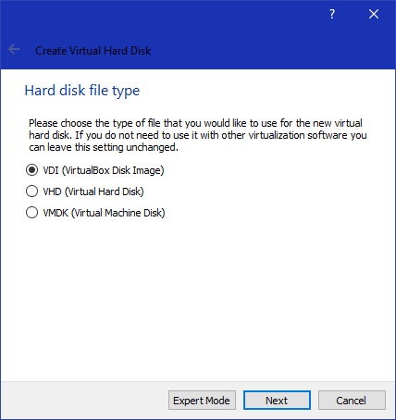Next, VirtualBox prompts for virtual hard disk type, the default of VDI (VirtualBox Disk Image) is fine. Select it and click “Next”.
6. 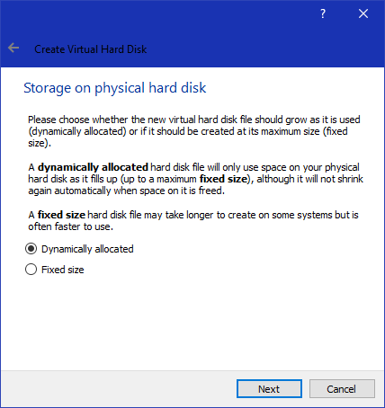Next, VirtualBox prompts for physical disk allocation, either dynamic or fixed. The default of “Dynamically allocated” is fine, so select it and click “Next”.
7. 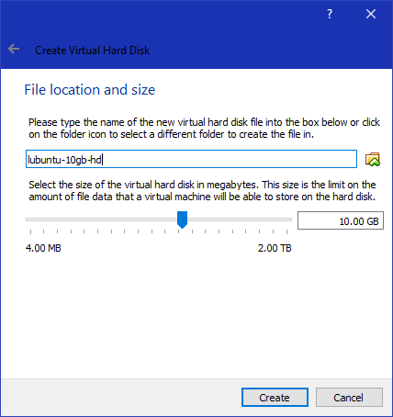Next, give the virtual hard disk a name and allocate the size of the VDI on the physical drive. The default size is 10 GB which is enough for Lubuntu. Click “Create”.
8. At this point, the VM will be created and VirtualBox returns to the home screen with the new VM added to the list of available virtual machines in a state of “Powered Off”. Click the new Virtual Machine in the list to select it.
9. 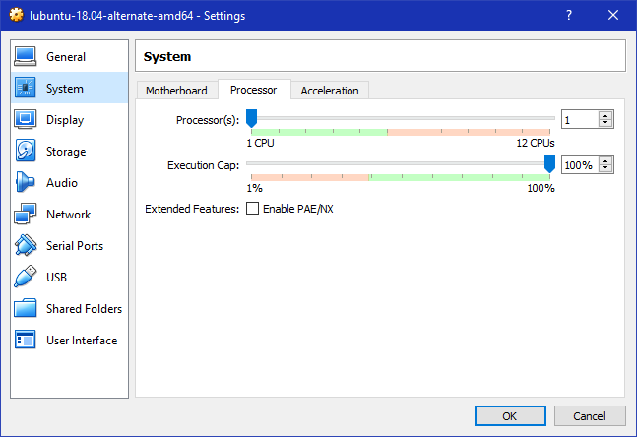By default, VirtualBox allocates 1 CPU (core) with a maximum execution cap of 100% (one full core). To view these settings or allocate a different number of CPUs or change the execution cap, click on Settings>System>Processor Tab.
10. 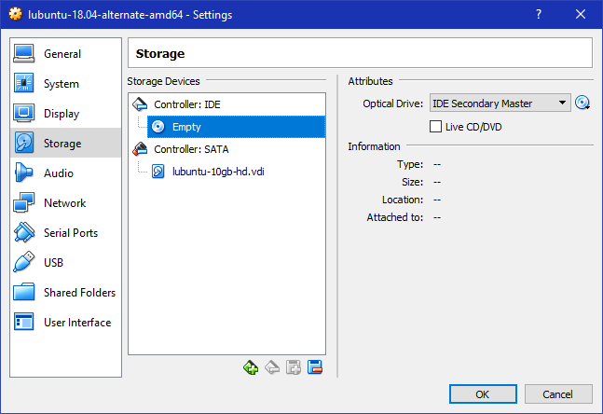Before starting the VM, it will need a boot medium. To insert virtual optical media, go to Settings>Storage. Under Controller: IDE, select the Empty drive. This will bring up additional information on the Optical drive on the right hand side.
11. 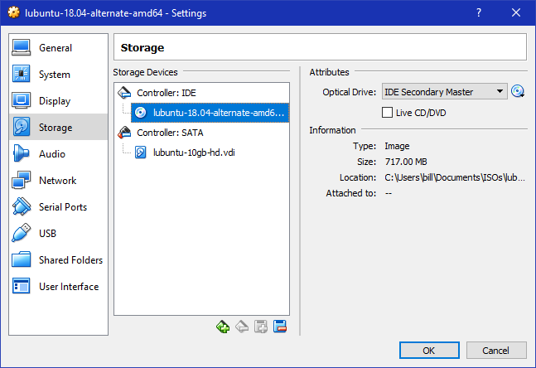From here, click on the image of a disk to the right of “Optical Drive:IDE Secondary Master” to browse for and open your Lubuntu ISO file. This inserts the Lubuntu file into the virtual optical drive. If you accidentally select the wrong ISO file, you can remove the ISO from the virtual optical drive by clicking the same image and selecting “Remove Disk from Virtual Drive”.
12. 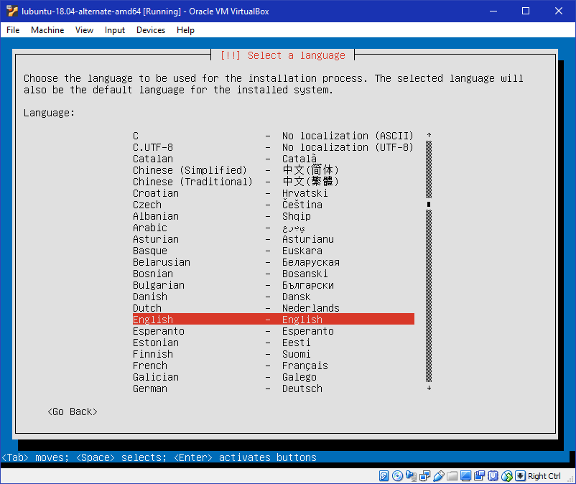Now we are ready to install the Lubuntu OS onto the virtual machine. From the VirtualBox home screen, select your VM and click “Start”. This will load the Lubuntu boot disk and you can install Lubuntu like you would normally on any physical machine.
13. 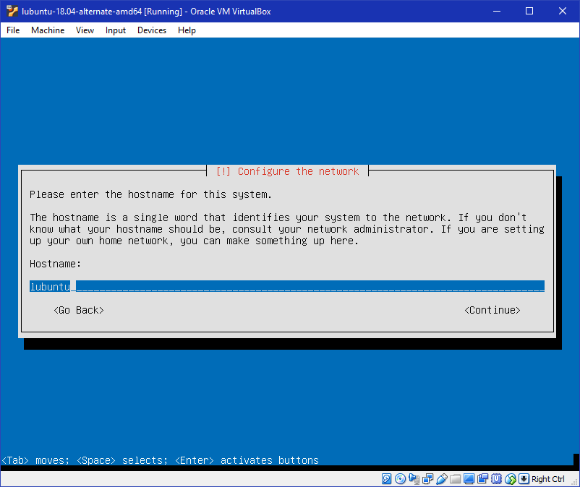Keep in mind that you cannot use the mouse for Lubuntu, so select the appropriate language options by hitting enter. The region and language settings default to English(US). After the language settings are selected, the next screen is network configuration where Lubuntu prompts for a hostname.
14. 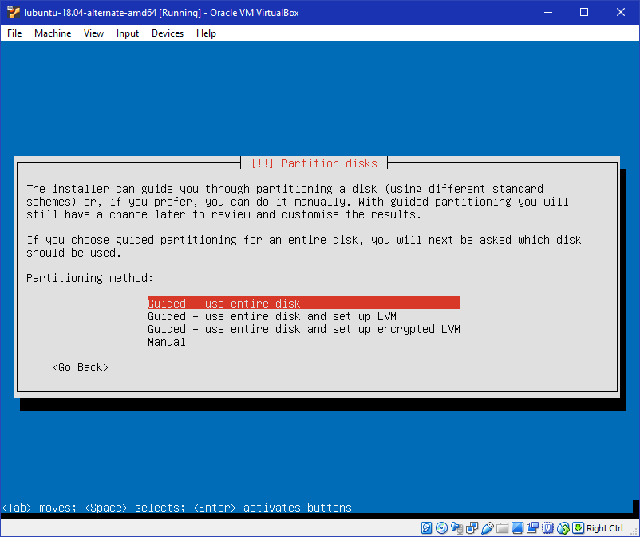Full name, user name, password, and time zone are all next. Use a strong password! After these are set up, next is partitions. Use “Guided – use entire disk” for a simple and fast setup.
15. 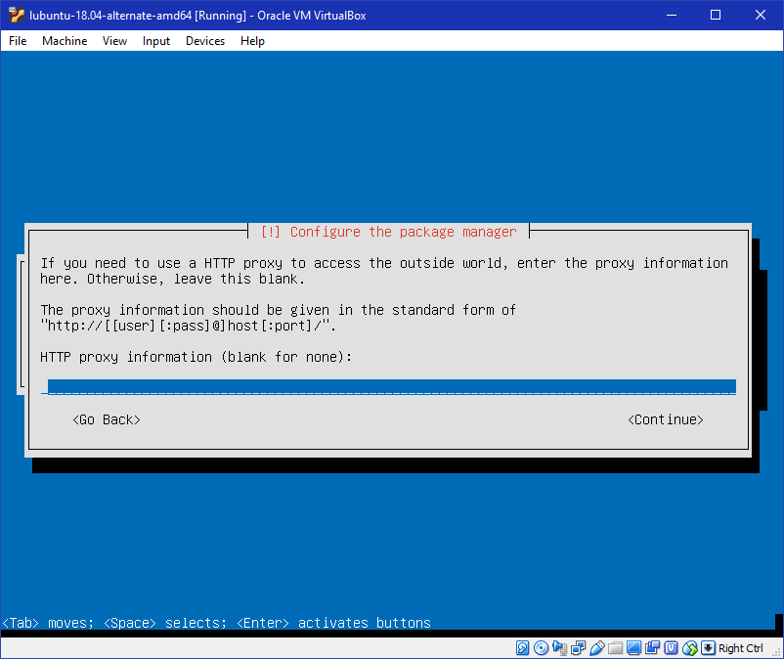The next screen prompts for a drive to install to. There should be only one – the virtual hard disk created earlier. Select it, and then on the next screen select yes to confirm installation of the OS to the virtual disk. This will take a few moments. The next steps configure the package manager. Insert your proxy information (or leave blank, for none).
16. 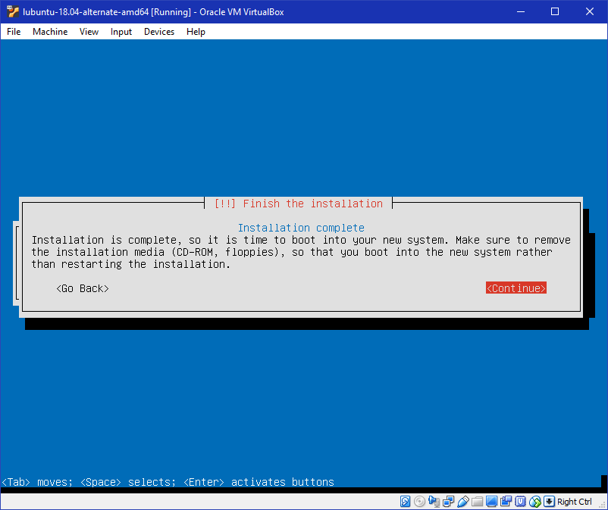There will be a few more minutes while the OS installs various components followed by a prompt for if you want to install GRUB. Select “Yes”. It will then prompt if system time is set to UTC, select “Yes” to finish installation. The installation will be complete, select “Continue”
17. 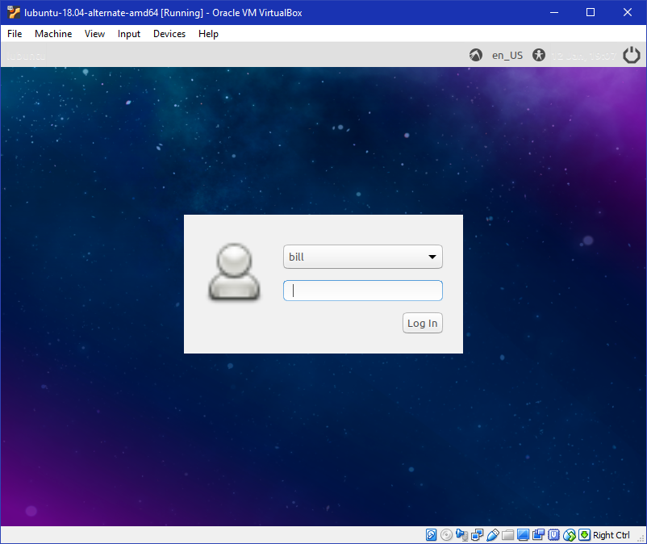The machine will reboot and VirtualBox will automatically dismount the ISO from the virtual drive. The machine will boot into Lubuntu which will prompt for a username and password.
18. Click the Lubuntu button and then click logout to bring up shutdown options. Select Shutdown to power off the virtual machine.

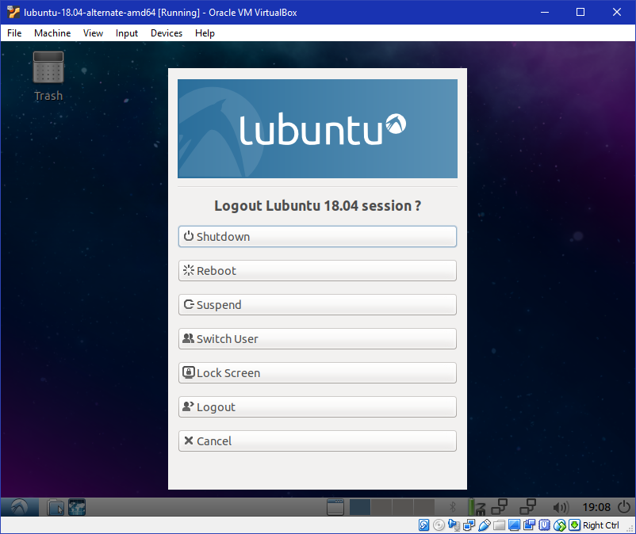

1. Congratulations! Your new Lubuntu virtual machine using VirtualBox is ready for use!